Family Tree
AIM:
To write a Prolog program to represent a family tree and identify family relationships using logical rules.
ALGORITHMS:
- Start.
- Define facts for male, female, and parent.
- Define rules for father, mother, sibling, brother, sister, and grandparent.
- Accept a query from the user.
- Match the query with the facts and rules using Prolog.
- Display the result. If another solution exists, use backtracking to find it.
- Stop.

CODE:
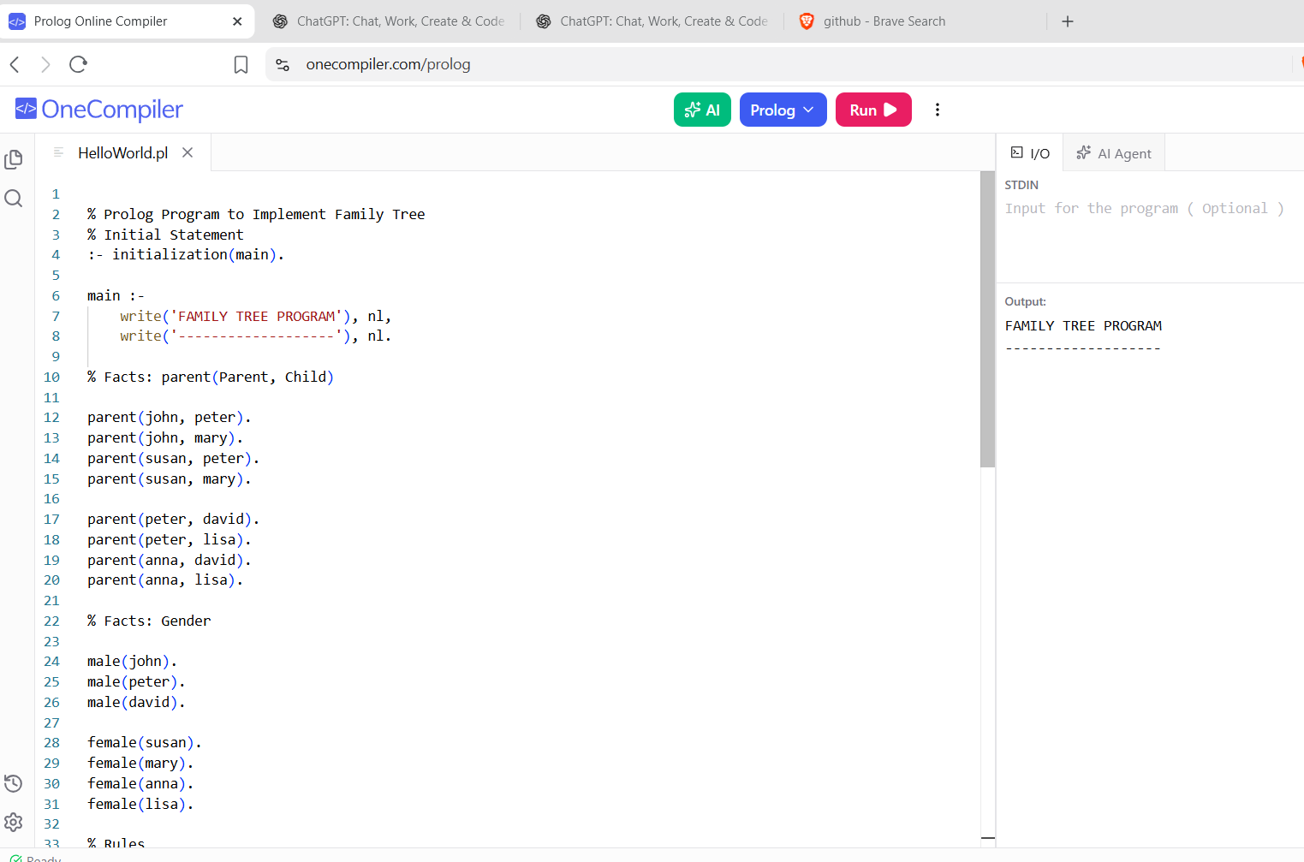

RESULT:
The family relationships, such as parent, father, mother, and ancestor, are identified successfully.

